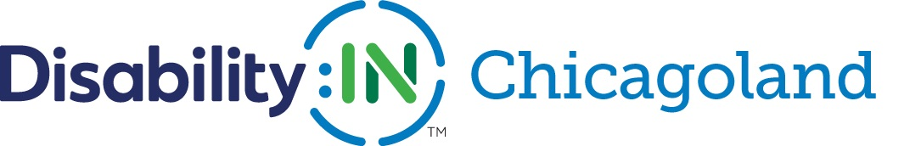

COVID-19 Accessibility & Disability Inclusion Resources

With offices closing and the shift to a remote workforce, many companies are experiencing new challenges in supporting their teams, especially those workers with disabilities. Online work platforms create new opportunities for flexibility but also can be isolating to individuals accustomed to working in teams. As our partners work to support and respond to the needs of their workforce, we have compiled a list of useful COVID-19 resources, including information on accessibility, supporting mental health and disability inclusion.

General Information for Business & Workers with Disabilities:

- The ADA at Work, Considerations for COVID-19 – Employer Assistance and Resource Network on Disability Inclusion (EARN)
- The ADA, The Rehabilitation Act & COVID-19 – Equal Employment Opportunity Commission (EEOC) Fact Sheet
- Chicago Small Business Resiliency Fund – City of Chicago
- City of Chicago COVID-19 Response Center – City of Chicago
- Coronavirus Disease (COVID-19) Pandemic Updates – World Health Organization (WHO)
- COVID-19 Ask the EEOC: addressing questions on the pandemic and anti-discrimination laws – EEOC Webinar
- COVID-19 in the Workplace – Equip for Equality
- COVID-19 Resources for the Disability Community – Access Living
- COVID-19 Response Series – Disability:IN
- How to prepare and take action for COVID-19 – Centers for Disease Control and Prevention (CDC) Guidelines
- Pandemic Preparedness in the Workplace & the ADA – EEOC Fact Sheet
- Social Stigma Associated with the Coronavirus – World Health Organization (WHO)
- Tips for Social Distancing, Quarantine, and Isolation During an Infectious Disease Outbreak – Substance Abuse and Mental Health Services Administration (SAMHSA)
Accessibility Resources:

- Accessible Technology Procurement Toolkit – Disability:IN
- Accessibility Strategies for Deaf & Hard of Hearing People in Remote Meetings – HearingTracker.com
- Coronavirus Information in ASL – National Association of the Deaf (NAD)
- COVID-19 Videos in ASL - CDC
- CaptionAccess – online CART, video remote interpreting and captioning services
Resources on Supporting Mental Health During Infectious Disease Outbreaks:

- Coronavirus & Mental Health: Taking Care of Ourselves During Infectious Disease Outbreaks – American Psychiatric Association (APA)
- COVID-19 Mental Health Information & Resources – National Alliance on Mental Illness (NAMI)
- COVID-19: Managing Stress & Anxiety – CDC
- Mental Health & COVID-19 – Information and Resources – Mental Health America
- Taking Care of Your Mental Health in the Face of Uncertainty – American Foundation for Suicide Prevention
- Working Remotely During COVID-19 Your Mental Health & Well Being - American Psychiatric Association Foundation Center for Workplace Mental Health
Relief Funds:

- Chicago Community COVID-19 Response Fund – a collaboration between the City of Chicago, The Chicago Community Trust and United Way of Metro Chicago to unite the funds raised by Chicago’s philanthropies, corporations and individuals to be disbursed to nonprofit organizations across the region.

