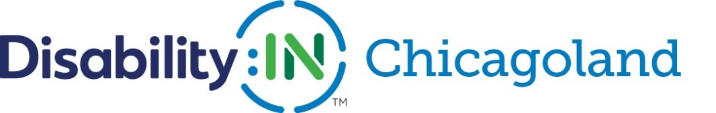

DISABILITY:IN CHICAGOLAND 2020 CALENDAR
January 2020
Friday, January 31 | DEI registration closes
February, 2020
Thursday, February 20 | Disability:IN Chicagoland Advisory Board Meeting | Q1 Board and Advisory Committee meeting
Friday, February 28, 12:00-1:30 | Disability:IN Affiliate Call | Creating Efficiencies among your Diversity Programs: Exploring the Intersection of Race, Women and Disability
March, 2020
Wednesday, March 18, 8:00-10:00 am (Postponed, date TBD) | Disability:IN Chicagoland Event @ CDW | Recruiting, Hiring & Accommodating Neurodiverse Workers
April, 2020
Friday, April 10 | DEI responses due
Tuesday, April 21, 8:00-9:30 am  (Event moved online, in person event date TBD) | Disability:IN Chicagoland event @ Comcast | Understanding & Building Performance, Influence & Exposure as an E/BRG Leader
Friday, April 24, 12:00-1:30 | Disability:IN Affiliate Call | Autism@Work Hiring Programs
May, 2020
Wednesday, May 6, 5:00-7:00 pm (Postponed, date TBD) | Disability:IN Chicagoland Event @ Deloitte | From the Periphery Book Discussion & Networking with author Pia Justesen
Tuesday, May 12, 8:30-9:30 am | Disability:IN Chicagoland Webinar sponsored by CDW | Supporting the Mental Health of Your Remote Workforce
June, 2020
Thursday, June 4 | Disability:IN Chicagoland Advisory Board | Q2 Board and Advisory Committee meeting
Wednesday, June 24 | Disability:IN Chicagoland Webinar sponsored by Comcast & Great Lakes ADA Center | A Discussion of the Digital Accessibility of Online Remote Work Platforms
July, 2020
Monday, July 13 – Thursday July 16 | Disability:IN Annual conference in Orlando
Saturday, July 25 | Disability Pride Parade
Sunday, July 26 | 30th Anniversary of the ADA
August, 2020
Thursday, August 6, time TBD | Disability:IN Chicagoland Event with Shirley Ryan Ability Lab | Accommodating Workers with Disabilities After COVID-19
September, 2020
Thursday, September 17 | Disability:IN Chicagoland Advisory Board | Q3 Board and Advisory Committee meeting
Friday, September 25, 12:00-1:30 | Disability:IN Affiliate Call | Deaf Culture and ASL for Beginners
October, 2020 | National Disability Employment Awareness Month
November, 2020
Friday, November 20, 12:00-1:30 | Disability:IN Affiliate Call | The Changing Workforce and Workplace
December, 2020
Thursday, December 10 | Disability:IN Chicagoland Advisory Board | Q4 Board and Advisory Committee meeting

